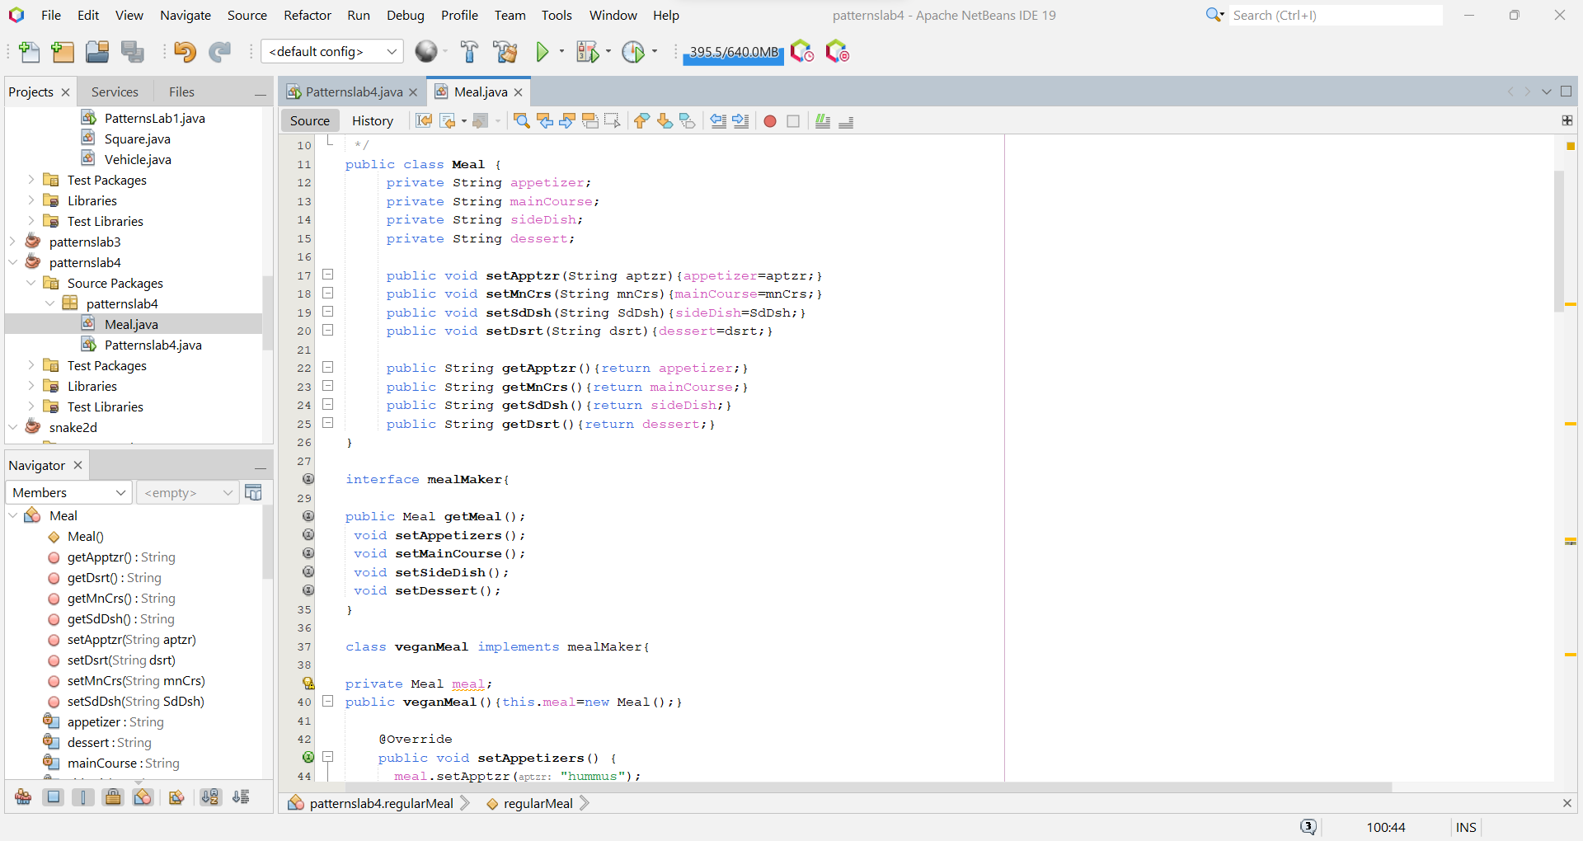Assignment 1:

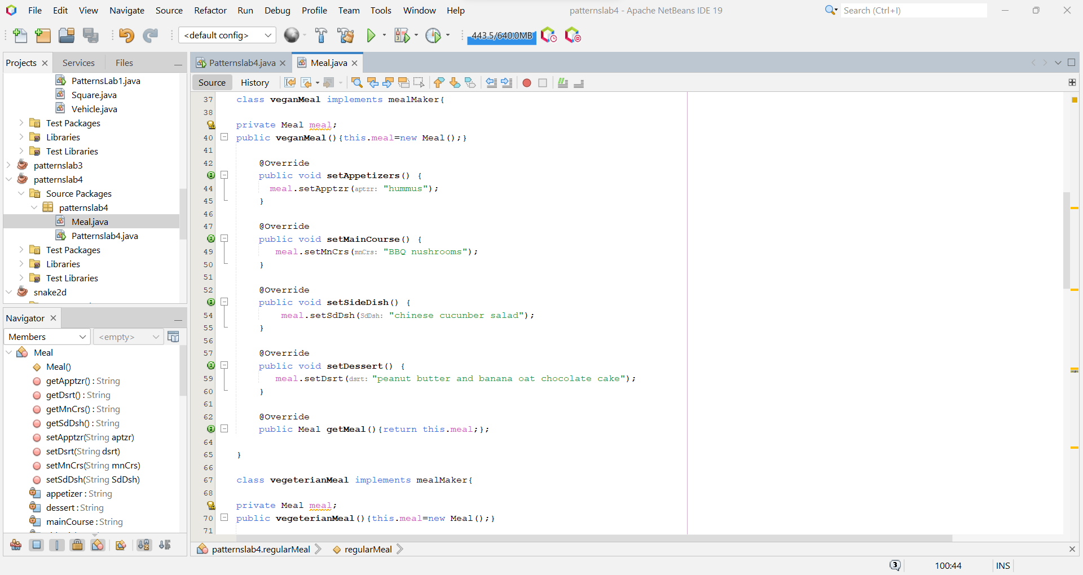

Run:

Class diagram:

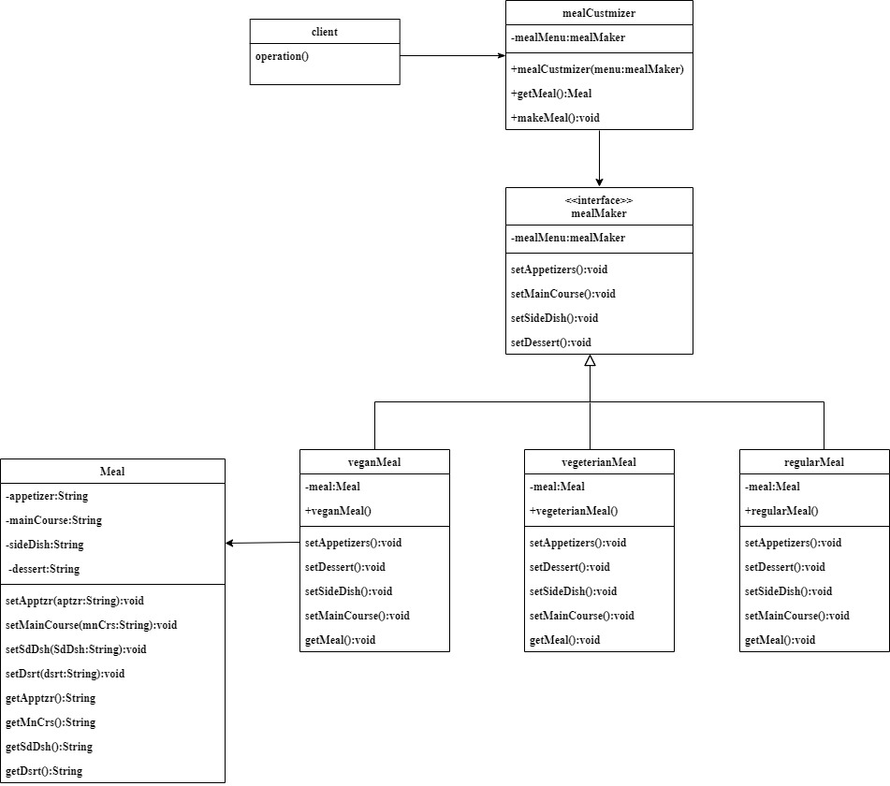

Assignment 2:



